Important action following needle-stick and sharps injuries

Sharps including needles or syringes should not be handled as stated in the do’s and don’ts guidance– for removal please report via ‘Report a problem’ link on the Volunteer litter picking scheme council website.
To prevent injuries litter picking tongs provided by the council should be used when picking up litter.
Bags of rubbish or bins should not be sorted through.
Any fly tipping should be reported to the council for removal using the ‘Report a problem’ link on the Volunteer litter picking scheme council website.

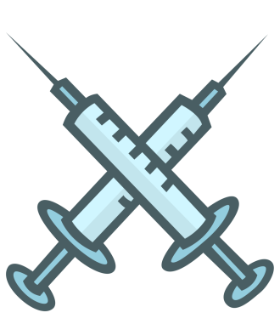
If an injury does occur the following steps should be followed:

1. Do not suck the wound
2. Encourage the wound to bleed, ideally by holding it under running water
3. Wash the wound using running water and plenty of soap
4. Do not scrub the wound while you're washing it
5. Dry the wound and cover it with a waterproof plaster or dressing
6. Pick up needle with litter picking tongs (NOT your hands) if safe to do so
7. Place in suitable container
8. Take the needle in suitable container to the A and E department of the nearest hospital and report the
Injury to them
9. Give them the container with the needle inside for identification purposes
10. When possible contact the council for an incident report form and when completed please return it to the council

