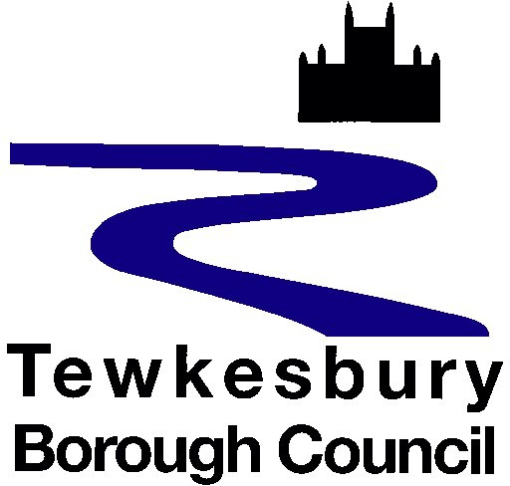

Planning and enforcement Privacy Notice

Why we collect information about you
We are the planning and enforcement team for Tewkesbury Borough Council. This privacy notice explains how we use information in the course of our work as a local planning authority. This work comprises making decisions and providing advice on planning applications and dealing with breaches of planning law.

What information do we collect about you?
We collect information about you for the purposes of carrying out our functions as a local planning authority. These include:
- Making decisions and providing advice on planning applications
- Providing pre-application advice
- Investigating and responding to allegations of unlawful development
- Serving enforcement notices
- Processing appeals on enforcement and planning decisions
- Environmental impact assessment screening and scoping opinions
- Entering Section 106 agreements
- Seeking responses from consultees
- Enabling representation from members of the public
- Serving Tree Preservation Orders
- Answering general and technical enquiries from members of the public
- Facilitating duty planner appointments
- Pursuing the most effective use of land in the public interest

Who do we share the information with?
Your information may be shared within the council and with some external organisations. The council will never sell your information to anyone else.

We make details of planning applications we receive available online so that other people can contribute their comments.

To comply with our statutory obligations, we are required to make public certain details relating to planning applications, in the form of a public register. Therefore:
- We will publish the name of the person applying for planning permission along with their address. Where an agent is acting on their behalf, the name and address of that agent will be published. We will redact other personal information such as signatures, email addresses and telephone numbers (see redaction section below).

- We will publish comments received on planning applications by members of the public. We will redact personal details. If you make a comment on a planning application, please be aware that it will be made available for public viewing and should not contain any information that may be deemed offensive, or potentially offensive. The council reserves the right not to publish any representations that are considered to be defamatory, rude, contain inappropriate content or are not a material planning consideration.
- We will publish comments received on planning applications from statutory and non-statutory consultees and amenity groups.

We will sometimes need to share the information we have with other parts of the council – for example, to establish how long a building has been used as a dwelling or for the consideration of legal planning advice.

We send some planning applications to our statutory consultees for their advice on safety, infrastructure and other matters. We will sometimes need to share information submitted in support of, or relevant to, the consideration of applications with specialist consultancies who sometimes assist with the processing of planning applications on behalf of the council.

In circumstances where a planning application is appealed, we are required to share data from a planning application with the Planning Inspectorate, which includes any comments made by statutory consultees and members of the public.

We also send a follow-up ‘customer satisfaction questionnaire” to every planning application and pre-application customer for comments about how we can improve our service.

Is any information transferred to or stored on servers based outside the European Union?
The information is stored on servers based in the UK.

How long do we keep your information?
Personal data will not be retained for longer than necessary. A summary of how long we keep documents before they are usually destroyed can be found on our corporate retention schedule Privacy and data protection.

Who do we collect information from?
Information held on our system is provided by applicants and agents when requiring a planning application service from the council or by interested parties when commenting or advising on planning applications.

Information is also provided by complainants and owners for planning enforcement matters.

What are the consequences if we do not collect the data?
The authority will be unable to fulfil its statutory planning obligation.

Are any decisions about you made by automatic means?
No decisions are made about you by automatic means.

Your rights as a data subject
By law, you have a number of rights as a data subject.

These rights are:
- Request access to your personal information (commonly known as a “data subject access request”). This enables you to receive a copy of the personal information we hold about you and to check that we are lawfully processing it.

- Request correction of the personal information that we hold about you. This enables you to have any incomplete or inaccurate information we hold about you corrected.

- Request erasure of your personal information. This enables you to ask us to delete or remove personal information where there is no good reason for us continuing to process it. You also have the right to ask us to delete or remove your personal information where you have exercised your right to object to processing (see below).

- Object to processing of your personal information where we are relying on a legitimate interest (or those of a third party) and there is something about your particular situation which makes you want to object to processing on this ground.

- Request the restriction of processing of your personal information. This enables you to ask us to suspend the processing of personal information about you, for example if you want us to establish its accuracy or the reason for processing it.

- Request the transfer of your personal information to another party.

All information is processed in accordance with Tewkesbury Borough Council’s data protection policy.

If you wish to review, verify, correct or request erasure of your personal information, object to the processing of your personal data, or request that we transfer a copy of your personal information to another party, please contact the council’s Data Protection Officer in writing at dpo@tewkesbury.gov.uk, or via post to:

Tewkesbury Borough Council Public Services Centre Gloucester Road Tewkesbury
GL20 5TT

If you are unhappy or wish to complain about how your personal data is used, you should contact Tewkesbury Borough Council’s Data Protection Officer in the first instance via email at dpo@tewkesbury.gov.uk.

If you are still not satisfied, you can complain to the Information Commissioners Office. Their website address is www.ico.org.uk and their postal address is:

Information Commissioner's Office Wycliffe House
Water Lane Wilmslow Cheshire SK9 5AF

Security

We use appropriate technical, organisational and administrative security measures to protect any information we hold in our records from loss, misuse, and unauthorised access, disclosure, alteration and destruction. We have written procedures and policies which are regularly audited, and the audits are reviewed at senior level.

