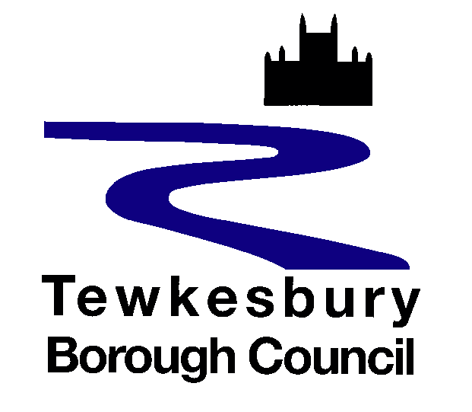
UKSPF/REPF Grants Applications Privacy Notice

For applications made under the UK Shared Prosperity Fund (including the Rural England Prosperity Fund), administered by the Ministry of Housing, Communities & Local Government (MHCLG), please read this Privacy Notice in conjunction with their Privacy Notice

Why we collect information about you?
In order to process your grant application.
What information do we collect about you?
- demographic and company information about your business/ organisation
- name and address
- contact information – email addresses and telephone numbers
- other information you have supplied in order to support your grant application such as financial information
Our legal basis for processing
We have a legal obligation to process grant applications and the lawful basis is UK GDPR Article 6(1)(c)

Who do we share the information with?
If you have made an application under the UK Shared Prosperity Funding your data will be shared with the UK Government Department - The Ministry of Housing, Communities & Local Government (MHCLG), Further information about how they process personal data collected is available in their Privacy Notice
Your details may be shared with all relevant internal / external partners involved in the delivery of support or funding offered, but this shall be communicated with you at that time.
We may share the information that we hold about you where it is necessary for us to do so in order to meet our legal obligations.
We will not pass or sell your personal data to third parties for marketing, sales or other commercial purposes.

Is any information transferred to or stored on servers based outside the UK?
Your personal data will not be sent overseas.

How long do we keep your information?
Your data will be held for as long as necessary in order to fulfil the purpose for which it was
collected. This does not affect your rights as outlined below.
We will only keep your data for the time specified in our retention policy or as required by law.

Are any decisions about you made by automatic means?
We do not carry out any automated decision making without human intervention.

Your rights as a data subject
By law, you have a number of rights as a data subject, and this does not take away or reduce these rights.

These rights are:
- Request access to your personal information (commonly known as a “data subject access request”). This enables you to receive a copy of the personal information we hold about you and to check that we are lawfully processing it.

- Request correction of the personal information that we hold about you. This enables you to have any incomplete or inaccurate information we hold about you corrected.

- Request erasure of your personal information. This enables you to ask us to delete or remove personal information where there is no good reason for us continuing to process it. You also have the right to ask us to delete or remove your personal information where you have exercised your right to object to processing (see below).

- Object to processing of your personal information where we are relying on a legitimate interest (or those of a third party) and there is something about your particular situation which makes you want to object to processing on this ground.

- Request the restriction of processing of your personal information. This enables you to ask us to suspend the processing of personal information about you, for example if you want us to establish its accuracy or the reason for processing it.

- Request the transfer of your personal information to another party.

All information is processed in accordance with Tewkesbury Borough Council’s data protection policy.

If you wish to review, verify, correct or request erasure of your personal information, object to the processing of your personal data, or request that we transfer a copy of your personal information to another party, please contact the council’s Data Protection Officer in writing at dpo@tewkesbury.gov.uk, or via post to:

Tewkesbury Borough Council
Public Services Centre
Gloucester Road
Tewkesbury
GL20 5TT

If you are unhappy or wish to complain about how your personal data is used, you should contact Tewkesbury Borough Council’s Data Protection Officer in the first instance via email at dpo@tewkesbury.gov.uk.

If you are still not satisfied, you can complain to the Information Commissioners Office. Their website address is www.ico.org.uk and their postal address is:

Information Commissioner's Office
Wycliffe House
Water Lane
Wilmslow
Cheshire
SK9 5AF

Security
We use appropriate technical, organisational and administrative security measures to protect any information we hold in our records from loss, misuse, and unauthorised access, disclosure, alteration and destruction. We have written procedures and policies which are regularly audited, and the audits are reviewed at senior level.

