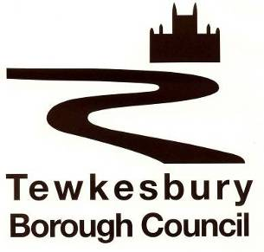
Simon Dix
Executive Director: Resources and S151

AUDIT OF ACCOUNTS YEAR ENDED 31 MARCH 2024

Publication of Tewkesbury Borough Council Statement of Accounts and Audit Opinion.

The Accounts and Audit (England) Regulations 2015 – Regulation 10, as amended by The Accounts and Audit (Amendment) Regulations 2022

The audit of the draft statement of accounts for the year ended 31 March 2024 for Tewkesbury Borough Council has not yet been completed by the external auditors, Bishop Fleming LLP. The Accounts and Audit (Amendment) Regulations 2022 require that the audited accounts and opinion are published by 30 September 2024.

The delay has arisen due to final accounts revisions being completed following the audit process however the sign off is expected to happen in November.

The Council will publish a final set of accounts as soon as the audit has concluded and the Audit Report issued.

This notice of delayed audit is being published in accordance with Regulation 10, paragraph (2a) of the Accounts and Audit Regulations 2015.

Simon Dix
Executive Director: Resources and s151 Officer
30 September 2024

