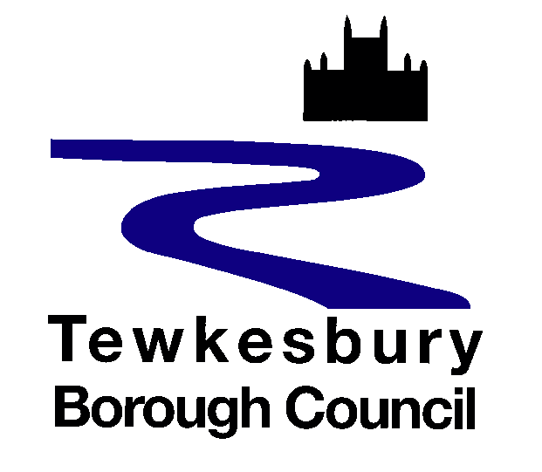
Garden Communities
Privacy Notice

Why we collect information about you
Tewkesbury Borough Council is undertaking engagement with stakeholders and members of the community to seek their views regarding the Tewkesbury Garden Communities programme. This Privacy Notice reflects the engagement aspect of the programme, statutory consultation for planning purposes shall be dealt with separately.
What information do we collect about you?
Name, email address, telephone number (where supplied)
Our legal basis for processing
The lawful basis for processing is UK GDPR Article 6(e) processing is necessary for the performance of a task carried out in the public interest.
Who do we share the information with?
Your information may be processed by external Consultants, who will process your data as a sub-processor under our instruction. We will anonymise data before sharing externally or publishing comments or views.
Is any information transferred to or stored on servers based outside the UK?
There may occasions where we transfer your data outside the UK. This is because we use software which is cloud hosted outside of the UK, and we may appoint a sub-processor to help us deliver this programme. In the event that an international data transfer is necessary we will ensure that your data is processed securely and that one of the following conditions are met:
- the country receiving the data is considered to provide an adequate level of data protection;
- the organisations receiving the data is covered by an arrangement recognised by the UK as providing an adequate standard of data protection;
- the transfer is governed by approved contractual clauses.

How long do we keep your information?
We keep data for only as long as is necessary and inline with the Councils’ Retention Schedule.
Who do we collect information from?
Stakeholders and members of the community who are participating in engagement activities such as workshops and surveys.
What are the consequences if we do not collect the data?
We would be unable to contact you to ask you to participate in further engagement activities.
Are any decisions about you made by automatic means?
No decisions will be made about individuals by automatic means.
Your rights as a data subject
By law, you have a number of rights as a data subject, and this does not take away or reduce these rights.

These rights are:
- Request access to your personal information (commonly known as a “data subject access request”). This enables you to receive a copy of the personal information we hold about you and to check that we are lawfully processing it.

- Request correction of the personal information that we hold about you. This enables you to have any incomplete or inaccurate information we hold about you corrected.

- Request erasure of your personal information. This enables you to ask us to delete or remove personal information where there is no good reason for us continuing to process it. You also have the right to ask us to delete or remove your personal information where you have exercised your right to object to processing (see below).

- Object to processing of your personal information where we are relying on a legitimate interest (or those of a third party) and there is something about your particular situation which makes you want to object to processing on this ground.

- Request the restriction of processing of your personal information. This enables you to ask us to suspend the processing of personal information about you, for example if you want us to establish its accuracy or the reason for processing it.

- Request the transfer of your personal information to another party.

All information is processed in accordance with Tewkesbury Borough Council’s data protection policy.

If you wish to review, verify, correct or request erasure of your personal information, object to the processing of your personal data, or request that we transfer a copy of your personal information to another party, please contact the council’s Data Protection Officer in writing at dpo@tewkesbury.gov.uk, or via post to:

Tewkesbury Borough Council
Public Services Centre
Gloucester Road
Tewkesbury
GL20 5TT

If you are unhappy or wish to complain about how your personal data is used, you should contact Tewkesbury Borough Council’s Data Protection Officer in the first instance via email at dpo@tewkesbury.gov.uk.

If you are still not satisfied, you can complain to the Information Commissioners Office. Their website address is www.ico.org.uk and their postal address is:

Information Commissioner's Office
Wycliffe House
Water Lane
Wilmslow
Cheshire
SK9 5AF
Security

We use appropriate technical, organisational and administrative security measures to protect any information we hold in our records from loss, misuse, and unauthorised access, disclosure, alteration and destruction. We have written procedures and policies which are regularly audited, and the audits are reviewed at senior level.

